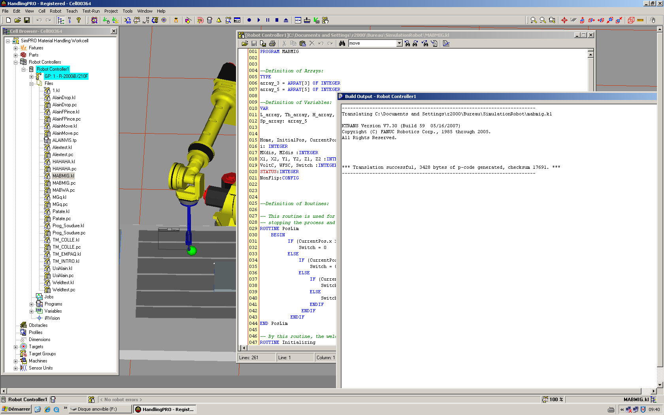

PROGRAM MABMIG

--Definition of Arrays:
TYPE
array_3 = ARRAY[3] OF INTEGER
array_5 = ARRAY[5] OF INTEGER

--Definition of Variables:
VAR
L_array, Th_array, H_array, Ag_array, V_array, WFS_array: array_3
Sp_array: array_5

Home, InitialPos, CurrentPos, Tmpp:XYZWPR
i: INTEGER
MXdis, MZdis :INTEGER
X1, X2, Y1, Y2, Z1, Z2 :INTEGER
VoltC, WFSC, Switch :INTEGER
STATUS:INTEGER
NonFlip:CONFIG

--Definition of Routines:

-- This routine is used for safety limits-- continue of the program if the destination be in the acceptable range
-- stopping the process and going to home position if the destination position be out of allowed range
ROUTINE PosLim
BEGIN
IF (CurrentPos.x >= X1) OR (CurrentPos.x <= X2) THEN
Switch = 0
ELSE
IF (CurrentPos.y >= Y1) OR (CurrentPos.y <= Y2) THEN
Switch = 0
ELSE
IF (CurrentPos.z >= Z1) OR (CurrentPos.z <= Z2) THEN
Switch = 0
ELSE
Switch = 1
ENDIF
ENDIF
ENDIF
END PosLim

-- By this routine, the welding torch goes near the welding starting point
ROUTINE Initializing
BEGIN
$SPEED=Sp_array[4]
$MOTYPE=LINEAR
MOVE NEAR CurrentPos BY (-25)
$SPEED=Sp_array[5]
--DOUT[38]=ON
MOVE TO CurrentPos
--DOUT[38]=OFF
END Initializing

ROUTINE Welding
BEGIN
DOUT[36]=OFF
--AOUT[3]=WFSC
--AOUT[4]=VoltC
DOUT[33]=ON --Contactor
DELAY 1000
--DOUT[38]=OFF --touch sensor
MOVE TO CurrentPos
DOUT[36]=OFF
--DOUT[38]=OFF
DOUT[33]=OFF
--AOUT[3]=0
--AOUT[4]=0
END Welding

-- This routine is used to remain a distance in the x-direction between the first, second, and third welding passes.
ROUTINE FreeMovement
BEGIN
CurrentPos.x=(CurrentPos.x-MXdis)
$SPEED=Sp_array[5]
$MOTYPE=LINEAR
MOVE TO CurrentPos
CurrentPos.x=(CurrentPos.x+MXdis)
MOVE TO CurrentPos
CurrentPos.z=(CurrentPos.z-MZdis)
MOVE TO CurrentPos
END FreeMovement

-- Routine for returning of robot arm to Home position after the process
ROUTINE Finishing
BEGIN
$SPEED=Sp_array[5]
MOVE AWAY (-50)
$SPEED=Sp_array[4]
MOVE TO Home
END Finishing

BEGIN
CNV_STR_CONF('N U T, 0, 0, 0',NonFlip,STATUS)
$MNUFRAMENUM[1]=2
$MNUTOOLNUM[1]=2
$GROUP[1].$UFRAME=$MNUFRAME[1,$MNUFRAMENUM[1]]
$GROUP[1].$UTOOL=$MNUTOOL[1,$MNUTOOLNUM[1]]

-- setting the initial values
FOR i=1 TO 3 DO
Th_array[i]=6
ENDFOR

FOR i=1 TO 3 DO
L_array[i]=100
ENDFOR

FOR i=1 TO 3 DO
H_array[i]=18
ENDFOR

FOR i=1 TO 3 DO
Ag_array[i]=10
ENDFOR

FOR i=1 TO 3 DO
V_array[i]=25
ENDFOR

Sp_array[1] = 100
Sp_array[2] = 200
Sp_array[3] = 300
Sp_array[4] = 400
Sp_array[5] = 50

WFS_array[1] = 550
WFS_array[2] = 660
WFS_array[3] = 550

MXdis=100 --mm
MZdis=100 --mm

X1=1650
X2=750

Y1=800
Y2=400

Z1=300
Z2=0

Switch = 1

WFSC=WFS_array[1]
VoltC=V_array[1]

Home=POS( 500.0, 767.0 , 200.0 , 0.0 , 0.0 , 0.0 , NonFlip )
InitialPos=POS( 827.0, 627 , 60 , 0.0 , 0.0 , 0.0 , NonFlip )
CurrentPos=InitialPos
--AOUT[3]=((WFS*4)-400) -- WFS 0 a max 2047 21 -> 593 mm/s
--AOUT[4]=(Voltage*40) -- Volts 0 a max 2047 10 -> 44 volts
-- AOUT[3]=550
-- AOUT[4]=1000

--Starting of program
$SPEED=Sp_array[4]
$MOTYPE=LINEAR
MOVE TO Home

CurrentPos.z=(CurrentPos.z + Th_array[1] + H_array[1]) --Adjusting the height of the torch
CurrentPos.p=Ag_array[1] --Adjusting the angle of the torch

-- making decision to continoue program or not based on the position limitation routine
PosLim
IF (Switch = 0) THEN
MOVE TO Home
ELSE
Initializing

CurrentPos.x=(CurrentPos.x+L_array[1]) --Adjusting the welding lenght
PosLim
IF (Switch = 0) THEN
MOVE TO Home
ELSE
$SPEED=Sp_array[1]
Welding
CurrentPos.z=(CurrentPos.z+MZdis)
CurrentPos.x=(CurrentPos.x+MXdis)

--checking the FreeMovement routine by the following PosLim routine
PosLim
IF (Switch = 0) THEN
MOVE TO Home
ELSE
FreeMovement
ENDIF
ENDIF
ENDIF

-- Continuing the welding process if the robot arm has not returned to the Home position in the previous steps
IF (Switch = 1) THEN
DELAY 2000
WFSC=WFS_array[2]
VoltC=V_array[2]
CurrentPos.z=(CurrentPos.z - Th_array[1] - H_array[1])
CurrentPos.z=(CurrentPos.z + Th_array[2] + H_array[2])
CurrentPos.p=Ag_array[2]
PosLim
IF (Switch = 0) THEN
MOVE TO Home
ELSE
MOVE TO CurrentPos

CurrentPos.x=(CurrentPos.x+L_array[2])
PosLim
IF (Switch = 0) THEN
MOVE TO Home
ELSE
$SPEED=Sp_array[2]
Welding
CurrentPos.z=(CurrentPos.z+MZdis)
CurrentPos.x=(CurrentPos.x+MXdis)
PosLim
IF (Switch = 0) THEN
MOVE TO Home
ELSE
FreeMovement
ENDIF
ENDIF
ENDIF
ENDIF

IF (Switch = 1) THEN
WFSC=WFS_array[3]
VoltC=V_array[3]
DELAY 2000
CurrentPos.z=(CurrentPos.z - Th_array[2] - H_array[2])
CurrentPos.z=(CurrentPos.z + Th_array[3] + H_array[3])
CurrentPos.p=Ag_array[3]
PosLim
IF (Switch = 0) THEN
MOVE TO Home
ELSE
MOVE TO CurrentPos

CurrentPos.x=(CurrentPos.x+L_array[3])
PosLim
IF (Switch = 0) THEN
MOVE TO Home
ELSE
$SPEED=Sp_array[3]
Welding
ENDIF
ENDIF
ENDIF

Finishing

END MABMIG

